Seminar Sheet 6
We are considering data structures and how we can eﬃciently store information. This seminar sheet is aimed at exploring and expanding on your current knowledge. Especially putting to use Maps, Sets and Arrays. In previous worksheets we looked at items, and inventories. The aim of this worksheet is to combine and build on the work you undertook in previous worksheets. Utilise the inventory and item systems you built in the past. You may need to evaluate the systems you built before to see if they are ﬁt for purpose with a crafting system. Research and design a simple crafting system. Consider how crafting systems operate within a variety of games and settle upon a design. Implement a simple crafting system, especially considering how you might represent recipes in your crafting system, and how you might enable designers to easily add new recipes without having to add additional code. You can choose to implement this seminar sheet in either blueprint, C++ or both. Crafting systems can be very simple or very complex. Consider your design carefully, and be careful not to over scope what you can create in the time frame. Think about the potential pitfalls, and make sure to thoroughly test your system. Think about how you might setup a crafting test level, with lots of resources so that you can make all of the items in your inventory etc.

Problem 1.
  - Research and design a crafting system. Draw upon ideas from games you have played or enjoyed. Consider how the system operates, and what the code requirements might be.
Looking into most crafting my most favourite types are pre-listed crafting, ones where you don’t need to know all the recepies, but instead it just tell you what is available to be crafted in a list
Terraria makes a good example of this as well as the new Minecraft crafting system with the recipe book, these are both examples i
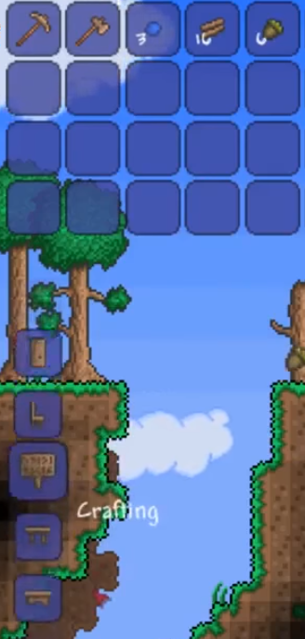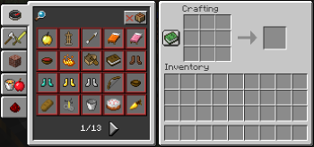

The one main Idea I have right now from working on the inventory system and the items I created was the Unturned crafting system. It works on similar items and a very simple crafting system displaying what can be made at the current time, also the recipes aren’t too complex
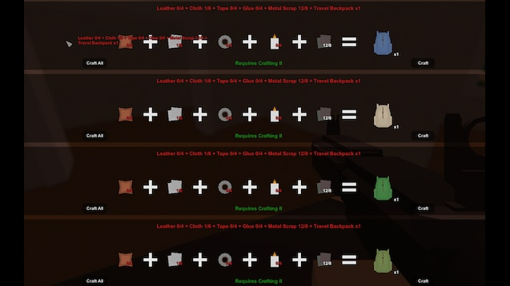

Problem 2.
  - Design the UML and consider the information you will need to store to represent the recipes / crafting materials. How will items be crafted, and how will the requirements be checked against your current items, however they are stored. Consider the interconnected systems of items, inventory, recipe, and ﬁnal produced crafted item. Think about the API and where the pitfalls and edge cases may exist. How are the Inventory, Crafting System, and Recipes going to communicate with each other. How does the player store current crafting recipes, and how can the crafting system resolve a recipe to craft an item.
With this system thinking ahead I will be uses the inventory and items I made in the previous system, with the addition of a few more crafting items. I will then also have to make changes to the inventory system to maybe better handle crafting, with the UI I already have this should be okay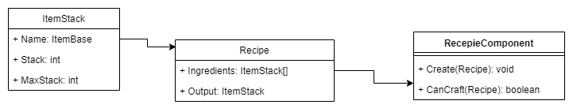
Looking at this I could also consider other ways of confirming that recipes can be crafted, such as just returning an array of available recipes to the UIWidget this I will explore during implantation which would be better.
This is the full crafting system design, covering most of the interaction between the different system and linking to the whole system.
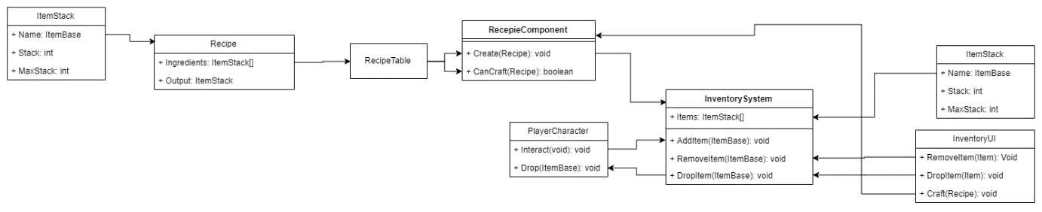

Problem 3.
  - Implement your UML diagram in either blueprint, C++ or both and create a recipe system.
For this I will Blueprint.
Starting the implantation I will load up the InventorySystem from Seminar Sheet 5 and use that as the base.
First I am creating the struct
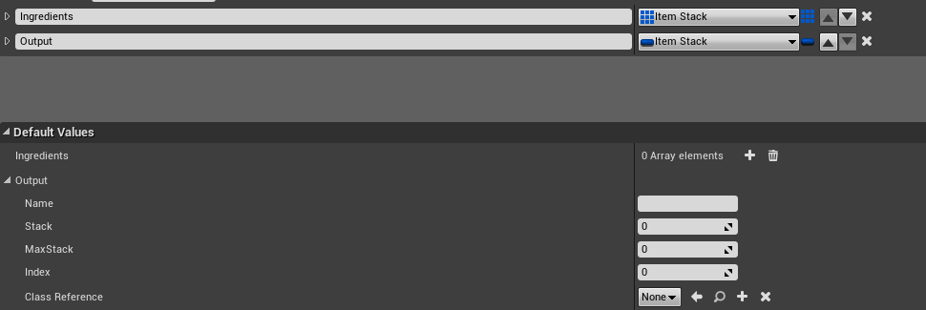
Then I need to create a datatable of this struct, starting this I’ve noticed that the MaxStack field is not useful to this but I’ve opted to still use ItemStacks as I would be able to use the output itemstack as a way of sending the output straight to the inventory. While the ingredients could change its type I feel like its simple to keep it the same (also now realising only the name and stack is useful)
My new decision is to create a new recipe struct using the class reference and a stack number, making it easier to compare the class / item type with that of the inventory
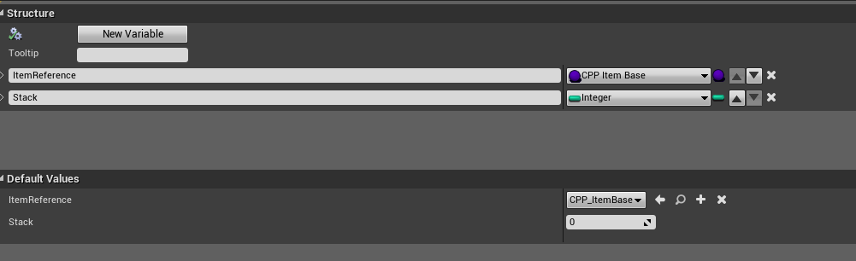

Now I can just use the class reference as a comparator (I could also make an ID system, but I don’t want to add it in now as it would cause a lot of refactoring. I would rather be building from the ground up keeping in mind of making a smart ID system)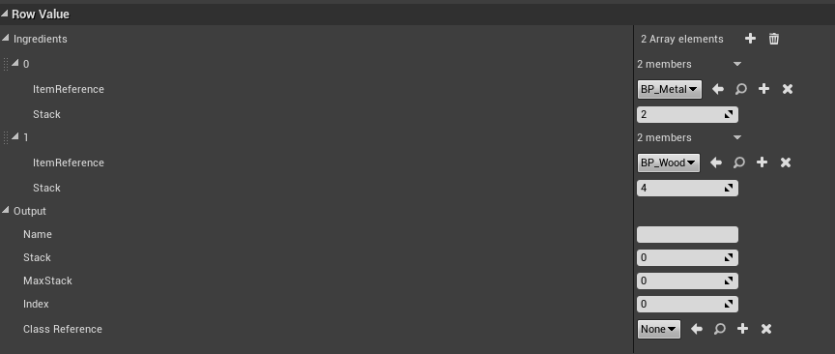
Now I can also control what gets sent straight into an inventory
Before finishing up I need to make a few recipes and that means I will need to add some more items
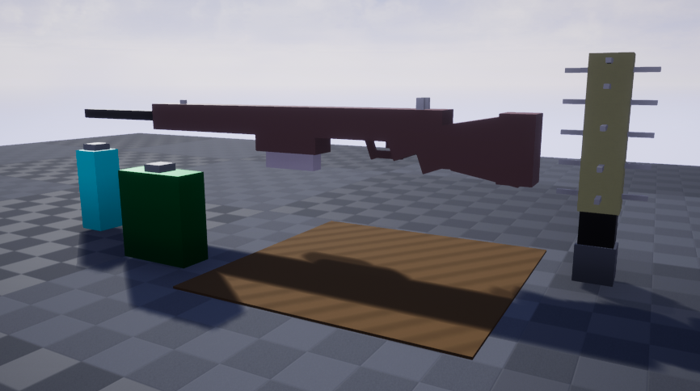I’ve added:
- Rifle
- Water Bottle
- Canteen
- Wooden Tile
- Spike Bat
I really took the idea of making some quick simple items myself from Unturned.
The only issue I had from here is manually setting up the item data within the object, I could’ve used a table to handle this but again, that would involve reworking the whole inventory system also.
Quickly before creating the recipes I will test these items work with the inventory system
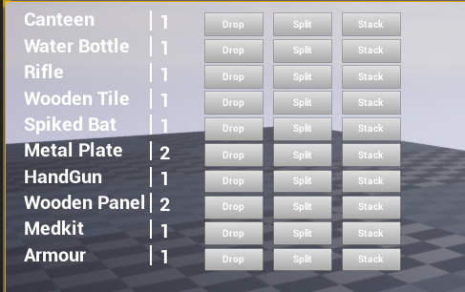
As it shows this work perfectly fine
Now the recipes
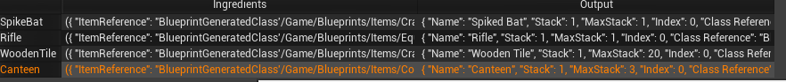
A basic set of 4 recipes.
So now the basics of the recipe system is done, time to get crafting.

Problem 4.
  - Implement your UML diagram in either blueprint, C++ or both and create a crafting system system that allows you to craft items based on recipes you have currently available.
Basic implantation into the Crafting Component I started with the can craft check
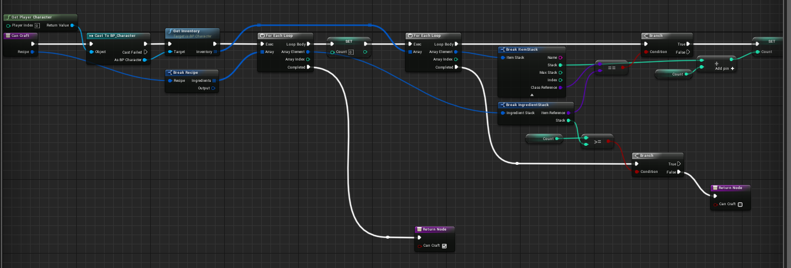
This returns a Boolean (true if can craft and false if cannot)
It check by counting all the items in the inventory of the right type and then comparing to each ingredient requirement
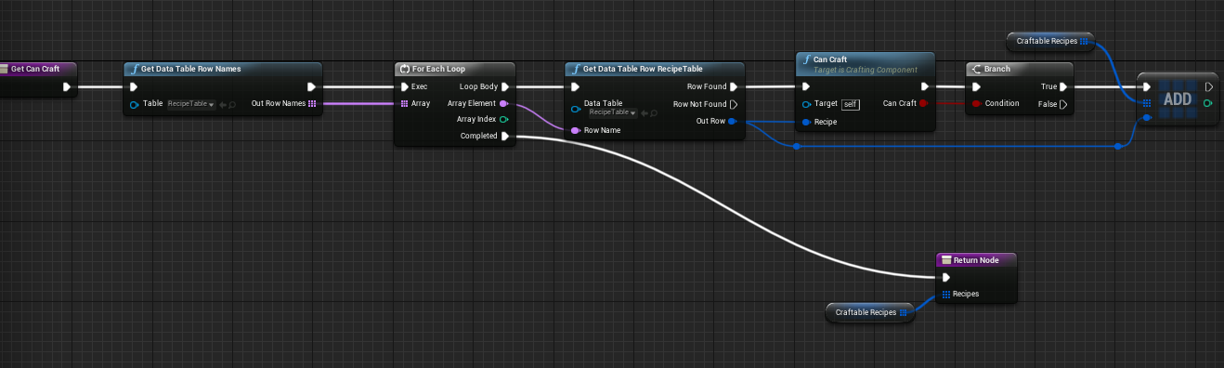
Now I can my another function utilising that to check all recipes and then returning the array
The craft function now also utilises the can craft function as an extra check
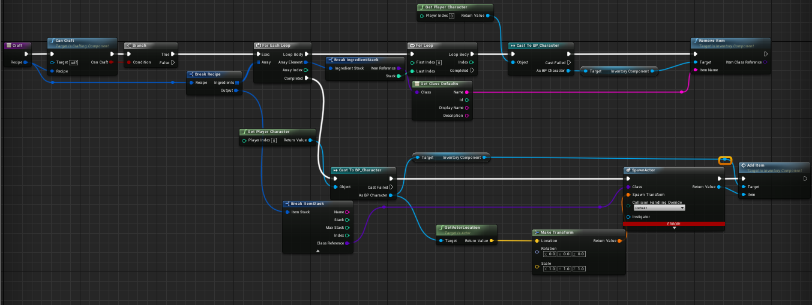
It checks it can craft before then removing the items from the inventory and then adding the new item to it, the item does have to be spawned in but is removed by the inventory manager on creation, as it is placed in the inventory. (Note I fixed the error as in the image by recompiling)

Problem 5 (Extension).
  - You may want to create a simple UI to show the recipes you have available. Create a system that shows missing components or materials. You could also create a multi-craft option. Expand your system. Does your current system support multiple recipes for the same item.
I haven’t done testing so far as to have the crafting functionality work with the UI.
First I need to modify the UI, the first move is to make the inventory menu also show the crafting menu
Using what I know the process should be very similar to what I have done before.
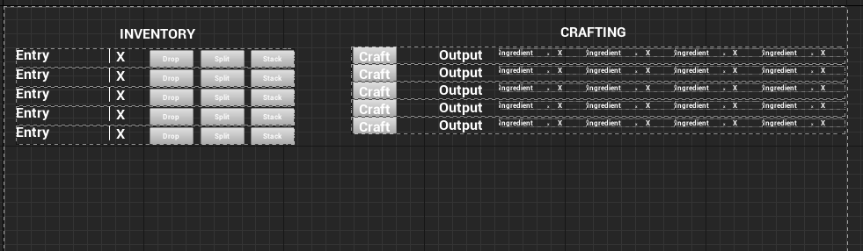
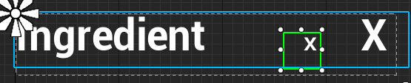
Now that I’m more confident with lists there a 2 more lists, one for all the recipes and another for each ingredient in said recipe.
First is to rig the crafting list to get the available recipes
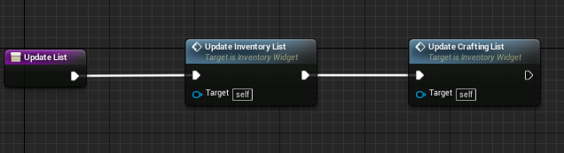
In the UI I made a separate Update function for both inventory and crafting, separating the inventory update into respective function.
Now to update the crafting List
This is the new update crafting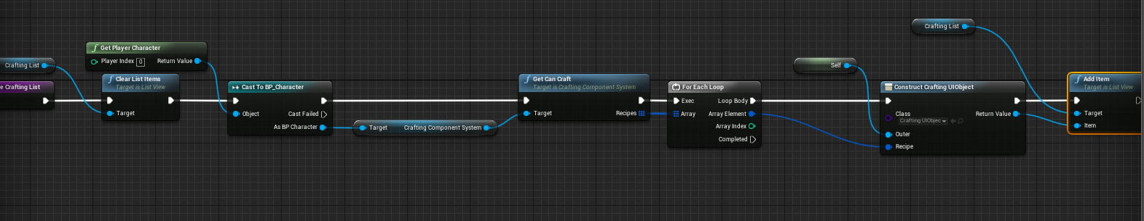
The Crafting Item Widget
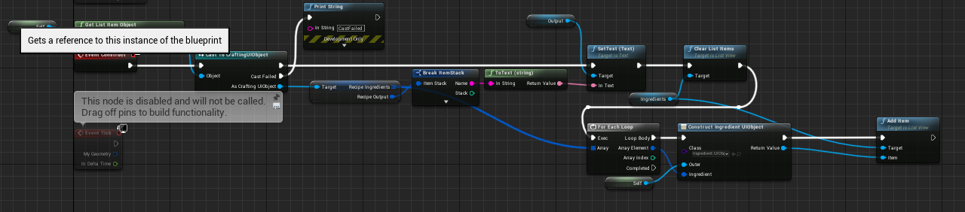
The Ingredients Display Widget
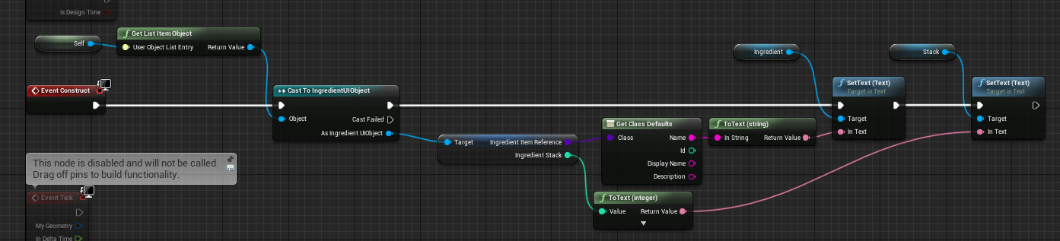
With all this in place time to do a test, I loaded up the old item test scene with the new items as well and got started, the first item to craft is the canteen
It requires 2 metal plates and a water bottle, as first attempts go it failed, while there is a new item in the crafting section the data displayed is incorrect, even though I have the correct ingredients.
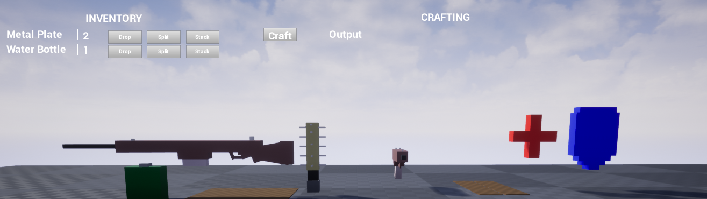
After a look the I discover the problem a few print blocks later, the construct line doesn’t carry the data it needed,
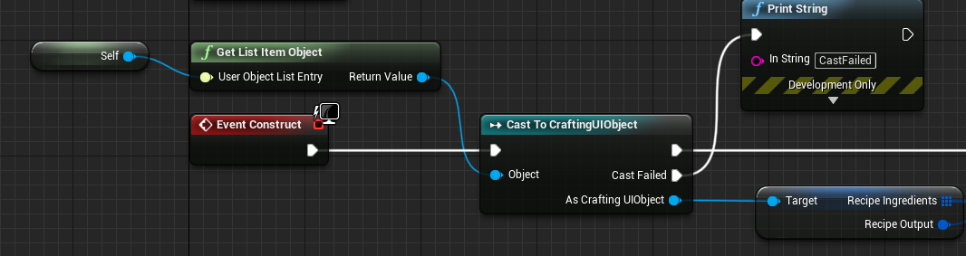
The cast at this stage fails even though I passes this object type, the object I get is a None type.
Looking into this I know my previous interaction with “Get List Item Objects” come from the bindings rather than the construct area.
So I create a bind to set the “output” text to be correct
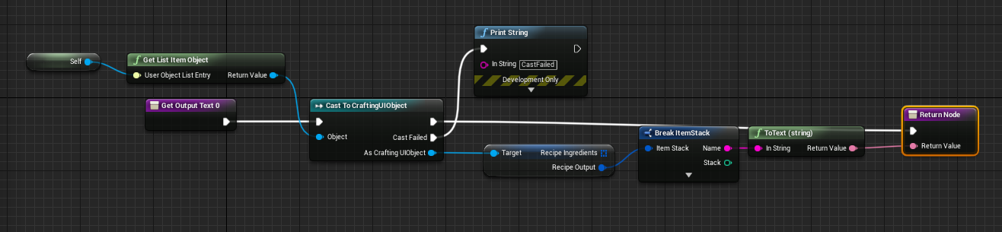
One test later and now I’m starting to understand this more
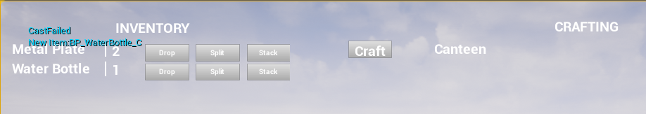
So I can only access the object data within a binding (or possibly another event that I’m not aware of)… speaking of another event.
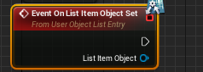
Found what I’m looking for, its also passing the object through this event so I think this saves a few nodes.
So a short rerouting later and time to try again, I also update the ingredient node as well
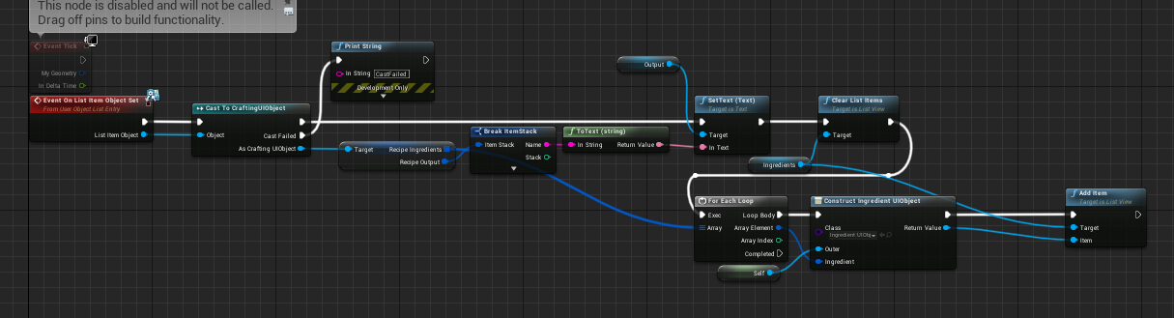
Here is the new attempt
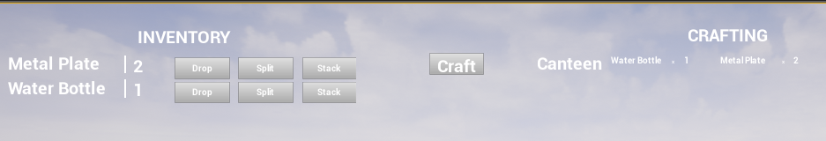
Working as intended, that’s great. Now I need the craft button to work. I’m also happy cause now I understand UMG a bit better.
I need to make a bind to the button to then grab the recipe and run that in the crafting component belonging to the player, similar to the buttons from the inventory list just a different component
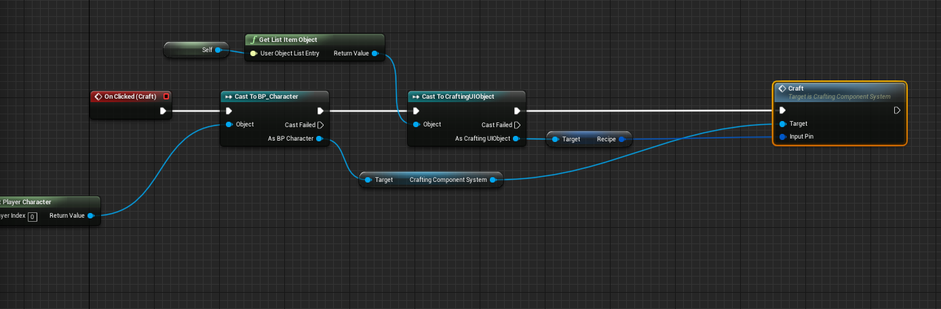
Hitting craft just cleared both sides?

Actually no, this is what it should’ve done, but I have a ghost field in the inventory
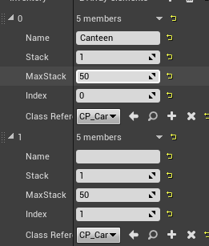
A quick check shows it a ghost of the crafted item, so one is right the other is wrong
Quick check in the inventory and crafting areas with a few prints I learn the add item is being called twice, the issue is I’m unsure why.
A long debug later an I realised I came to my own fault. The Canteen item is a consumable which I made pickupable on overlap, which was trigger upon spawning of the item but was remove, this called the add item function twice, one from crafting and another from the overlap but it was in removal causing issues with it being displayed. I wouldn’t have got this issue trying another recipe at the start
To rectify this I made the craft function instead spawn the item below the world so it would be away from the player
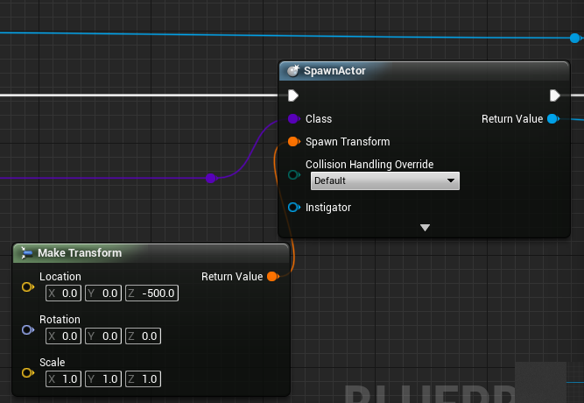
So when I try this again
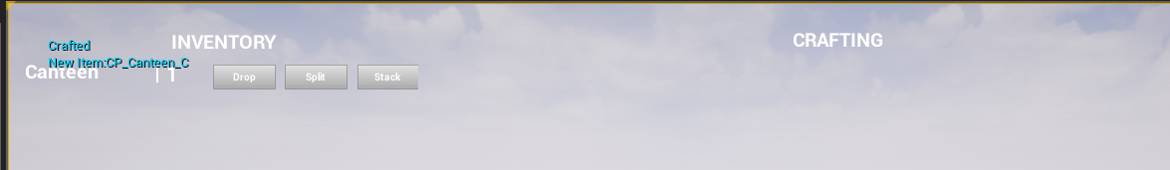
It displays correctly. I have no ghost item.
Now to test the other recipes, for this I picked up all items and manually filled the stacks
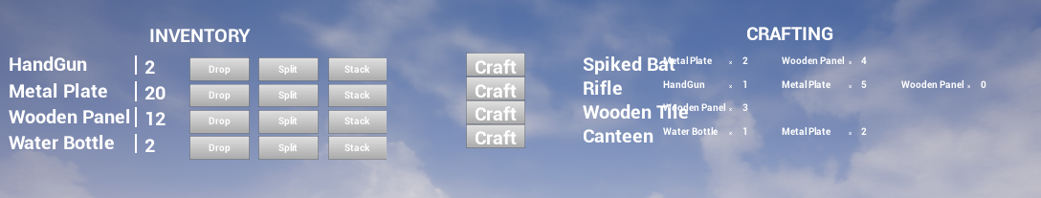
With that all 4 recipes display (text does overlap woops) and I can craft them accordingly
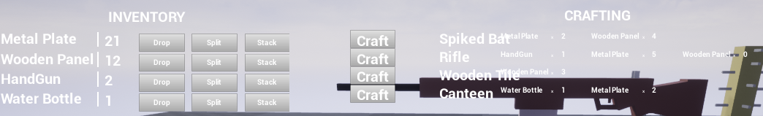

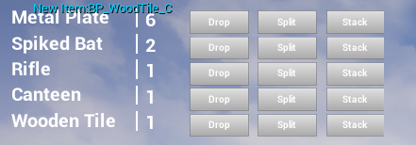
As it shows, the crafting UI now fully works.

I learned a lot more about the UMG system and using the correct events, I made some assumption where most errors occurred but even so I don’t think I could have predicted the errors beforehand. With this I’ve learnt how to overcome these sorts of issues and to be more aware of all my action with certain objects.
This concludes Seminar Sheet 6

